Pablo Moran Ruiz 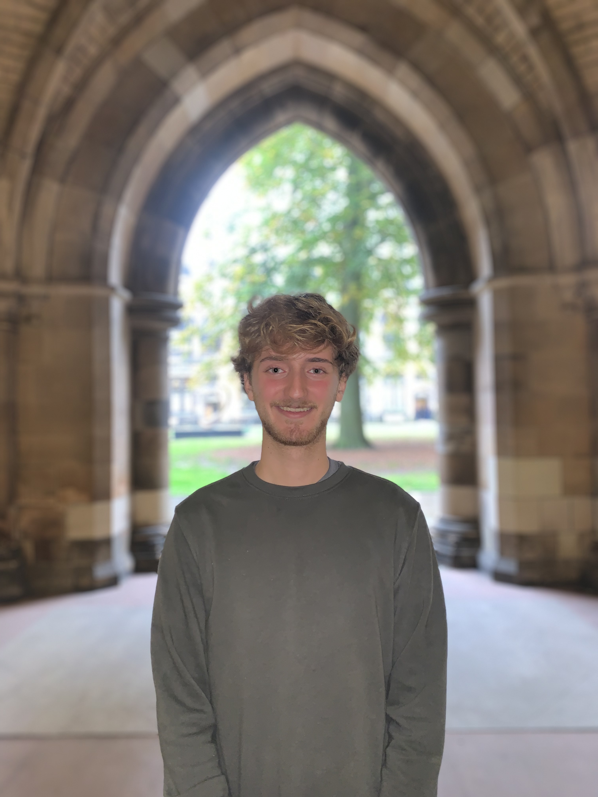
SRC Assessor

Pablo was elected to the Students’ Representative Council in the 2023 spring elections as the LGBTQ+ Officer. Subsequently, he was elected during the first Council meeting to sit on the University Court as the SRC Court Assessor.

As a fourth year Biomedical Engineering student, Pablo’s academic interests include research, healthcare, and innovation. He has always had a passion for public institutions, democracy, and student voice. He hopes to effectively represent the student body and bring their perspectives to Court through integrity and accountability and uphold the student representation values at the University’s highest level of representation.

Pablo was born in Madrid and came to Glasgow for the first time when he began his studies. He has only become more involved with University as time has passed, having been an SRC Welcome Helper in 2022 and 2023, actively involved in clubs and societies, such as being president of the Glasgow University Spanish Society, and having been a council member of the SRC for two years.

